Bachelor of Computer Applications
Semester – V
Business Analytics
Assignment No.: 06
Title: Sorting & Filtering Data in Power BI
Submitted By:
Name: Abhinav Abhilash
Reg. No.: 2411021240029
Date: 26 October 2026
Submitted To:
Faculty Name: Mr. Devatha Nikhil
Department of Computer Application
Alliance University
Chandapura - Anekal Main Road, Anekal
Bengaluru – 562106
Experiment: Sorting & Filtering Data in Power BI

Problem Statement
A sales manager needs a clear summary of sales performance, profitability, returns, and regional activity. The purpose of this experiment is to interpret the supplied Power BI dashboard and explain how its KPI cards and charts can support business decisions.

Objectives
- Summarize revenue, profit, return rate, and unit cost using KPI cards.
- Compare the quantity sold across the South, East, West, and North regions.
- Review the regional profit visual and identify what it communicates.
- Explain the value of dashboard visuals for sales monitoring and decision-making.
- Recommend improvements that make the dashboard easier to read and interpret.

Dataset and Dashboard Description
The analysis is based on the dashboard screenshot supplied for this assignment. The screenshot displays four KPI cards: Sum of Revenue ($), Total Profit, Return Rate %, and Sum of Unit Cost ($). It also contains a horizontal bar chart showing Sum of Quantity by Region and a column chart labelled Sum of Profit ($) by Region.
The screenshot does not show the underlying transaction rows or the exact filters applied. Therefore, the report uses the visible dashboard values and chart patterns only, without assuming additional transaction-level details.

Tools and Technologies
- Microsoft Power BI Desktop for dashboard creation and visualization.
- KPI/Card visuals for headline business metrics.
- Horizontal bar chart for comparing quantity across regions.
- Column chart for displaying regional profit information.

Dashboard Screenshot
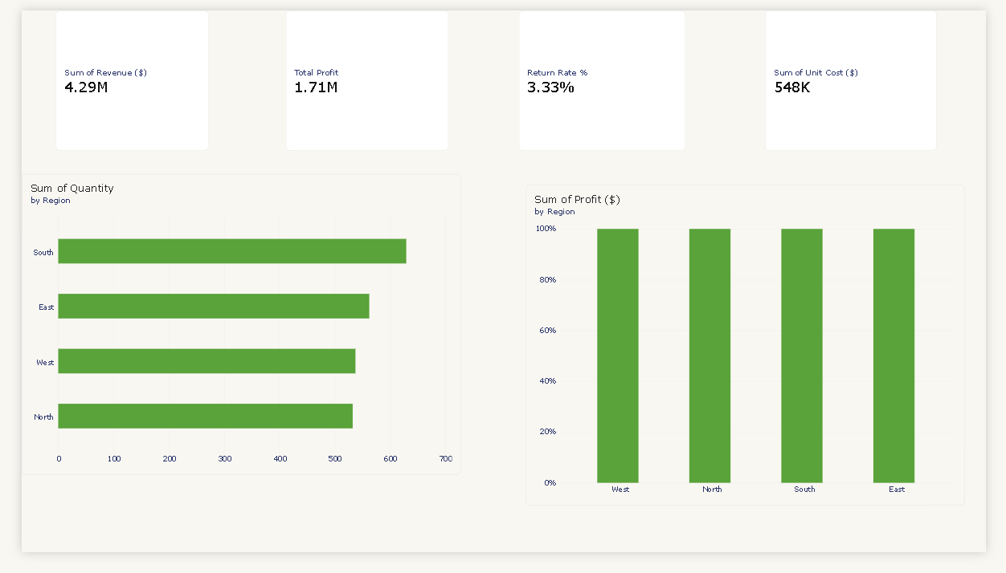
Figure 1: Sales performance dashboard supplied for analysis.

Methodology and Visual Analysis

1. KPI Cards
The first card reports total revenue of approximately $4.29 million. This represents the revenue shown for the current dashboard view. The second card displays total profit of approximately $1.71 million, indicating the profit value reported by the dashboard. The third card shows a return rate of 3.33%, while the fourth card shows unit cost of approximately $548K.
KPI cards make the most important values visible immediately. For a more complete view, the dashboard should use consistent currency formatting, descriptive labels, and the same number of decimal places where appropriate.

2. Quantity by Region
The horizontal bar chart compares the sum of quantity across four regions. Based on the visible bar lengths, South has the highest quantity, followed by East, West, and North. This allows the viewer to compare regional sales volume quickly.
The chart would be easier to interpret if data labels were enabled and the regions were sorted from largest to smallest. A clear axis title such as 'Units Sold' would also help confirm that the values represent quantity rather than revenue.

3. Profit by Region
The second chart is titled 'Sum of Profit ($) by Region'. However, its vertical axis runs from 0% to 100%, and all four columns reach 100%. This suggests that a 100% stacked column visual may have been selected, which normalizes each region to 100% rather than showing the actual profit amount.
To compare actual profit, replace this visual with a regular clustered column chart. Put Region on the X-axis and Sum of Profit ($) on the Y-axis, and format the Y-axis as currency. This will make differences between regions visible instead of displaying four equal-height columns.

Results and Findings
- The dashboard displays total revenue of approximately $4.29M.
- The dashboard displays total profit of approximately $1.71M.
- The return-rate KPI is 3.33%.
- The displayed sum of unit cost is approximately $548K.
- South appears to have the highest quantity among the four regions in the horizontal bar chart.
- The regional profit chart needs a visual-type correction because all columns show 100% on a percentage axis.

Recommendations
- Change the regional profit chart to a clustered column chart so actual profit values can be compared.
- Turn on data labels for the quantity-by-region chart.
- Use consistent titles, currency formats, font sizes, and spacing across all KPI cards and charts.
- Add slicers for Region, Category, Product, and Date if those fields are available in the underlying dataset.
- Check whether the return-rate measure is calculated as returned transactions divided by total transactions, and format it as a percentage.
- Include a clear dashboard title and a note indicating whether the KPIs represent the full dataset or a filtered selection.

Conclusion
The supplied dashboard gives a quick overview of revenue, profit, return rate, unit cost, and regional quantity. The KPI cards provide a useful summary, while the quantity chart helps compare sales volume across regions. The regional profit visual should be changed to a standard column chart to show actual profit values. With clearer labels, consistent formatting, and interactive slicers, the dashboard can provide more reliable and actionable insights for sales management.

Learning Outcomes
Through this experiment, I learned how to:
- Read and interpret KPI cards in a Power BI dashboard.
- Compare category-based values using a horizontal bar chart.
- Recognize when a 100% stacked chart is unsuitable for comparing absolute values.
- Improve chart readability through labels, sorting, axis formatting, and consistent layout.
- Translate dashboard observations into practical business recommendations.

